- Outline
• Linux History
• Design Principles
• System Overview
• Process Scheduling
• Memory Management
• File Systems
• Interprocess Communication
- History of Linux
• Free operating system based on UNIX standards.
• UNIX is a proprietary OS developed in the 60’s, still used for mainframes.
• First version of Linux was developed in 1991 by Linus Torvalds.
• Goal was to provide basic functionality of UNIX in a free system.
• Version 0.01 (May 1991): no networking, ran only on 80386-compatible Intelprocessors and on PC hardware, had extremely limited device-drive support, and supported only the Minix file system.
• Version 2.6.34 (Summer 2010): most common OS for servers, supports dozens of file systems, runs on anything from cell phones to super computers.
- Linus Torvalds
• Started the Linux kernel while a Masters student in Finland in 1991.
• About 2% of the current Linux code was written by him.
• Remainder is split between 1000s of other contributors.
• Message with the first Linux release:
• “PS.... It is NOT portable (uses 386 task switching etc), and it probably never will support anything other than AT-harddisks, as that's all I have :-( “
• Now supports pretty much any hardware platform...
- Design principles
- Linux is a multiuser, multitasking operating system with a full set of UNIXcompatible tools
• Its file system adheres to traditional UNIX semantics, and it fully implements the standard UNIX networking model.

• Main design goals are speed, efficiency, and standardization.
• The Linux kernel is distributed under the GNU General Public License (GPL), as defined by the Free Software Foundation.
• “Anyone using Linux, or creating their own derivative of Linux, may not make the derived product proprietary; software released under the GPL must include its source code”.

- Linux kernel vs Linux distributions:
• The Linux kernel is the core part of the operating system.
• scheduler, drivers, memory managers, etc.
• A Linux distribution is the kernel plus the software needed to make the system actually usable.
• user interface, libraries, all user level programs, etc.

Linux Structure
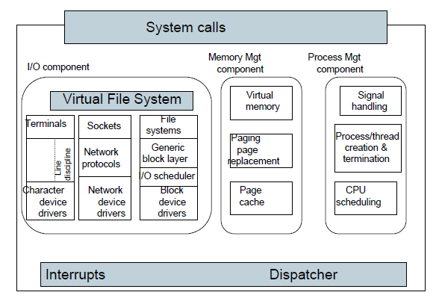
Structure of the Linux kernel

• Linux separates user and kernel mode to provide protection and abstraction.
• The OS functionality is split between the main Linux Kernel and optional kernel modules.
• Linux Kernel - all code that is needed as soon as the system begins: CPU scheduler, memory managers, system call / interrupt support, etc.
• A monolithic kernel - benefits?
• Kernel modules - extensions to the kernel that can be dynamically loaded or unloaded as needed: device drivers, file systems, network protocol, etc
• Provides some modularity - benefits?
• Can specify whether each OS component is compiled into the kernel or built as a module, if you build your own version of Linux from source code.

- Kernel Modules
• Pieces of functionality that can be loaded and unloaded into the OS
- Does not impact the rest of the system
- OS can provide protection between modules
- Allows for minimal core kernel, with main functionality provided in modules
• Very handy for development and testing
- Do not need to reboot and reload the full OS after each change
• Also, a way around Linux’s licensing restrictions: kernel modules do not need to be released under the GPL
- Would require you to release all source code.

• Kernel maintains tables for modules such as:
  - Device drivers
  - File Systems
  - Network protocols
  - Binary formats
• When a module is loaded, add it to the table so it can advertise its functionality.
• Applications may interact with kernel modules through system calls.
• Kernel must resolve conflicts if two modules try to access the same device, or a user program requests functionality from a module that is not loaded.

- Process management:
• Processes are created using the fork/clone and execve functions
- fork - system call to create a new process
- clone - system call to create a new thread
• Actually just a process that shares the address space of its parent
• execve - run a new program within the context created by fork/clone
• Often programmers will use a library such as Pthreads to simplify API
• Linux maintains information about each process:
  - Process Identity
  - Process Environment
  - Process Context
Process identity
• General information about the process and its owner.
• Process ID (PID) - a unique identifier, used so processes can precisely refer to one another.
• ps -- prints information about running processes.
• kill PID -- tells the OS to terminate a specific process.
• Credentials - information such as the user who started the process, their group, access rights, and other permissions info.
- Process context
• The dynamically changing state of the process.
• Scheduling context - all of the data that must be saved and restored when a process is suspended or brought into the running state.
• Accounting information - records of the amount of resources being used by a process.
• File table - list of all files currently opened by the process.
• Signal-handler table - lists how the process should respond to signals.
• Virtual memory context - describes the layout of the process’s address space.

- Process Scheduling
The Linux scheduler must allocate CPU time to both user processes and kernel tasks (e.g. device driver requests)
• Primary goals: fairness between processes and an emphasis on good performance for interactive (I/O bound) tasks
• Uses a preemptive scheduler
• What happens if one part of the kernel tries to preempt another?
  - Prior to Linux 2.4, all kernel code was non-preemptable
  - Newer kernels use locks and interrupt disabling to define critical sections
• Scheduler implementation has changed several times over the years
• Kernel 2.6.8: O(1) scheduler
- Used multi-level feedback queue style scheduler
- Lower priority queues for processes that use up full time quantum
- All scheduling operations are O(1), constant time, to limit scheduling overhead even on systems with huge numbers of tasks
• Kernel 2.6.23: Completely Fair Scheduler
  - Uses red-black trees instead of run queues (not O(1))
  - Tracks processes at nano-second granularity -> more accurate fairness

- Linux memory management
User processes are granted memory using segmented demand paging
  - Virtual memory system tracks the address space both as a set of regions (segments) and as a list of pages
• Pages can be swapped out to disk when there is memory pressure
  - Uses a modified version of the Clock algorithm to write the least frequently used pages out to disk
• Kernel memory is either paged or statically allocated
  - Drivers reserve contiguous memory regions
  - The slab allocator tracks chunks of memory that can be re-used for kernel data structures

Caches
• Linux maintains caches to improve I/O performance.
• Buffer Cache - stores data from block devices such as disk drives.
- All pages brought from disk are temporarily stored in buffer cache in case they are accessed again.
• Page Cache - caches entire pages of I/O data.
- Can store data from both disks and network I/O packets.
• Caches can significantly improve the speed of I/O at the expense of RAM.
- Linux automatically resizes the buffer and page caches based on how much memory is free in the system.
- File Systems
• Virtual File System layer provides a standard interface for file systems.
  - Supports file, inode, and file-system objects.
  - Lets the OS treat all files identically, even if they may be on different devices or file systems.
• Uses multi-level indexes to store and locate file data.
- Up to 3 levels of indirection.
- Allows for very large files.
- Still has good performance for small files.
• Uses (small) 1KB blocks on disk.
- Allocator places blocks near each other to maximize read performance.

